Sri Lanka Institute of Information

Technology



Lab Submission

<Lab sheet No 10>

**<IT24101016>**

**<Jayasooriya J.M.V.D.>**

**Probability and Statistics| IT2120**

B.Sc. (Hons) in Information Technology

**Exercise**

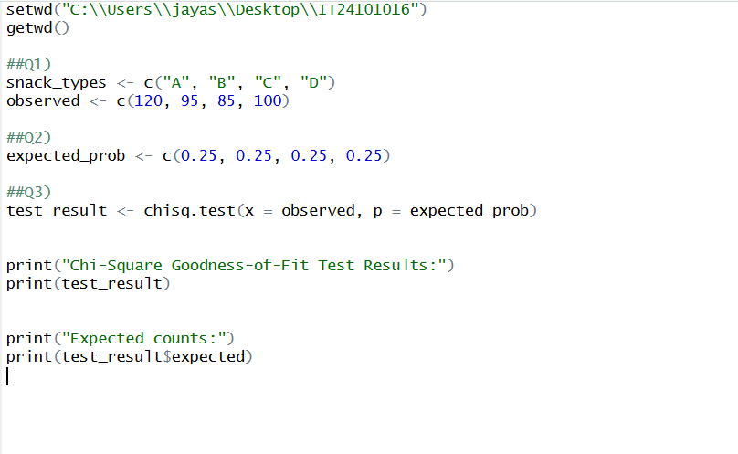

Answers

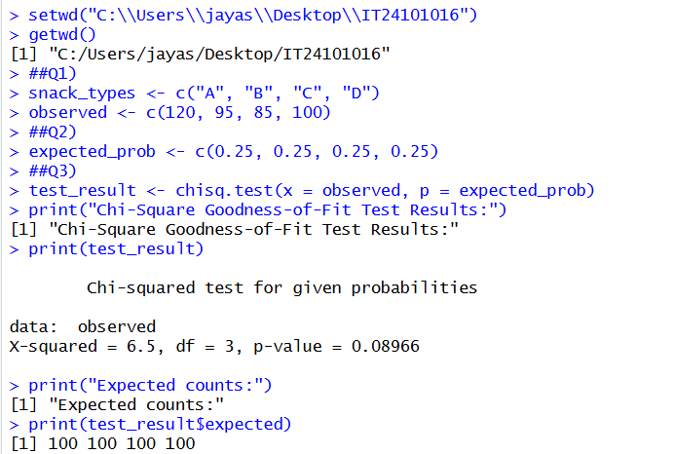

Final Data

